HIBERNATE AND SPRINGBOOT INTEGRATION

AOP

- Joinpoint - it represent the method execution.
- Pointcut : joint point execution made by pointcut expression
It has different expression for execution
- Within : it can be class , Package , or method
- Target : Can be any component which has been annotated
- Args Arguments can be retrieved from the JoinPoint

Different kinds of Advice
- Before
- After
- After returning
- After throwing
- Around

@Component
Class Student
{

}

@Aspect
Class AOPDefined
{

@before(“execution( * com.*Student.(..))”)

}

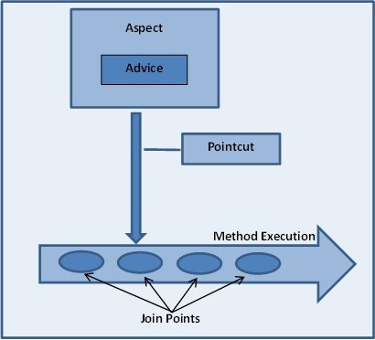

@Repository

stereotype for persistence layer

@Service

@Services hold business logic and call method in repository layer.

@Component is equivalent to
<bean>
@Service, @Controller, @Repository = {@Component + some more special functionality}
That mean Service, The Controller and Repository are functionally the same.
The three annotations are used to separate "Layers" in your application,
- Controllers just do stuff like dispatching, forwarding, calling service methods etc.
- Service Hold business Logic, Calculations etc.
- Repository are the DAOs (Data Access Objects), they access the database directly.
Now you may ask why separate them: (I assume you know AOP-Aspect Oriented Programming)
Let's say you want to Monitors the Activity of the DAO Layer only. You will write an Aspect (A class) class that does some logging before and after every method of your DAO is invoked, you are able to do that using AOP as you have three distinct Layers and are not mixed.
So you can do logging of DAO "around", "before" or "after" the DAO methods. You could do that because you had a DAO in the first place. What you just achieved is Separation of concerns or tasks.
Imagine if there were only one annotation @Controller, then this component will have dispatching, business logic and accessing database all mixed, so dirty code!

@Transactional

